7/30/2022

IGIRANEZA Josue

University of Rwanda – CST - SoICT

**Final Report Hostel Allocation Web App**

***Project title: E-Thesis Archiving – Case of Final Year Project, Department of Computer and Software Engineering – SoICT, UR***

**Submitted by**: **221026624**

**Year 2, CSE**

**Academic year 2021-2022**

Table of Contents

LIST OF FIGURES 2

1. Introduction 3

1.1 Project Summary 3

1.2 Problem statement 3

1.3 Objectives 3

1.4 Project Rationale 3

2. Methodologies and Methods 3

2.1 Data collection methodology 3

2.2 Tools to be used 3

2.2.1 Hardware tools 3

2.2.2 Software tools 3

3. System Analysis and Design 3

3.1 Requirement Specifications 3

3.1.1 Functional requirements 3

3.1.2 Data Requirements 3

3.1.3 User Requirements 3

3.1.4 Security Requirements 3

3.1.5 Non-functional Requirements 3

3.2 System Design 4

3.2.1 System overall architecture 4

3.2.2 System information flow 4

4. System Implementation 4

4.1 Landing page 4

4.2 Login page 5

4.3 And so on, at least 5 pages of you 6

5. Conclusion 7

6. Recommendation 7

7. Appendix 7

# LIST OF FIGURES

Figure 1: Overall structure 3

Figure 2: Project landing page 4

Figure 3: Login page 4

Figure 4: List of users 5

Figure 5: User details 5

Figure 6: Edit option 6

# Introduction

## Project Summary

The Hostel Allocation Web App is a web application whose purpose is to provide hostels to students at every start of the academic year.

It can also be used by Wardens to view a multitude of information on students

In order to coordinate the allocation of rooms.

## Problem statement

Every start of the academic year, many students from around the country come to live in hostels and it becomes a mess because the students are many and everything is done with paper and hands.

This is also a burden on the wardens because the number of students is too big and they have to provide rooms to thousands of students and this takes too much time to the point some students have to wait days just to get a room.

## Objectives

1. To reduce the amount of time it takes to get a hostel room.
2. To reduce the amount of paperwork used during the allocation of rooms
3. To reduce the disorganization in the current hostel allocation system

## Project Rationale

The project will benefit most f all students because it will reduce the amount of time it took to get a hostel and filling paperwork . It will also ease the work of wardens because of the reduction in paperwork.

# Methodologies and Methods

## Data collection methodology

Data was collected through Observation

## Tools to be used

### Hardware tools

* Personal computers (PCs)

### Software tools

* Student info databases
* Other databases

# System Analysis and Design

## Requirement Specifications

### Functional requirements

* E.g.: User authentication module, user registration modules…

### Data Requirements

* 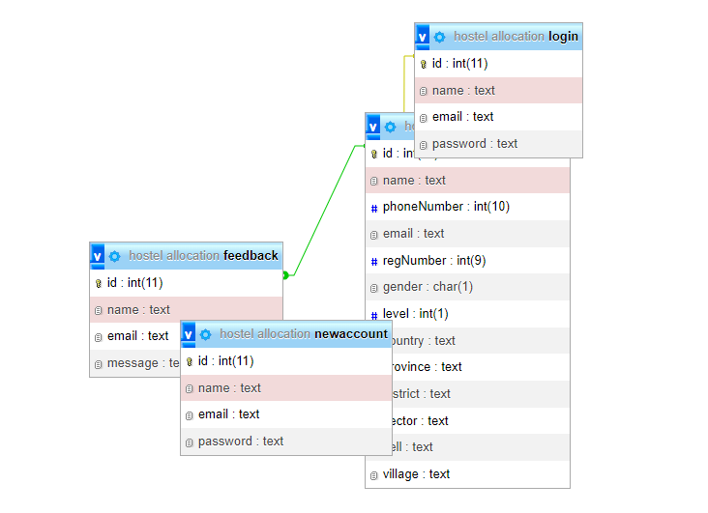

### User Requirements

* Main admin
* Wardens (admins)
* Sudents (users)

### Security Requirements

* The app requires a strong password

### Non-functional Requirements

* The system performs well on all kinds of devices
* The System is reliable
* It is accessible using any browser (Some functionalities won’t function in internet explorer)

## System Design

### System overall architecture

* E.g.: overall system flow.

Figure 1: Overall structure

### System information flow

* Flow chart for Login, user registration, and Booking process.

# System Implementation

* Some screenshots.

## Landing page

This picture detail the landing page of the Project. From the picture you can see all the pages that the user can access like the application page, status page, feedback page and others .

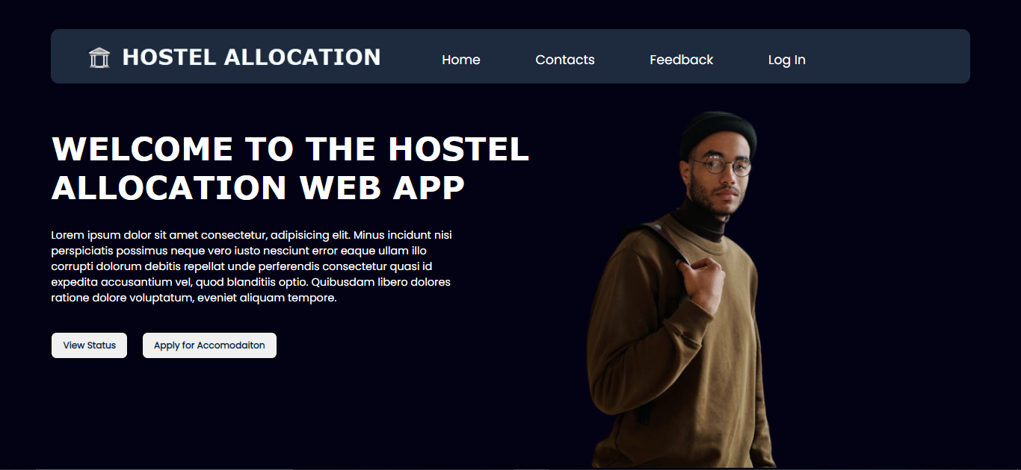

Figure 2: Project landing page

## Login page

This page details the login details like the name, email and password and when the user doesn’t have an account he/she can click in the create account link.

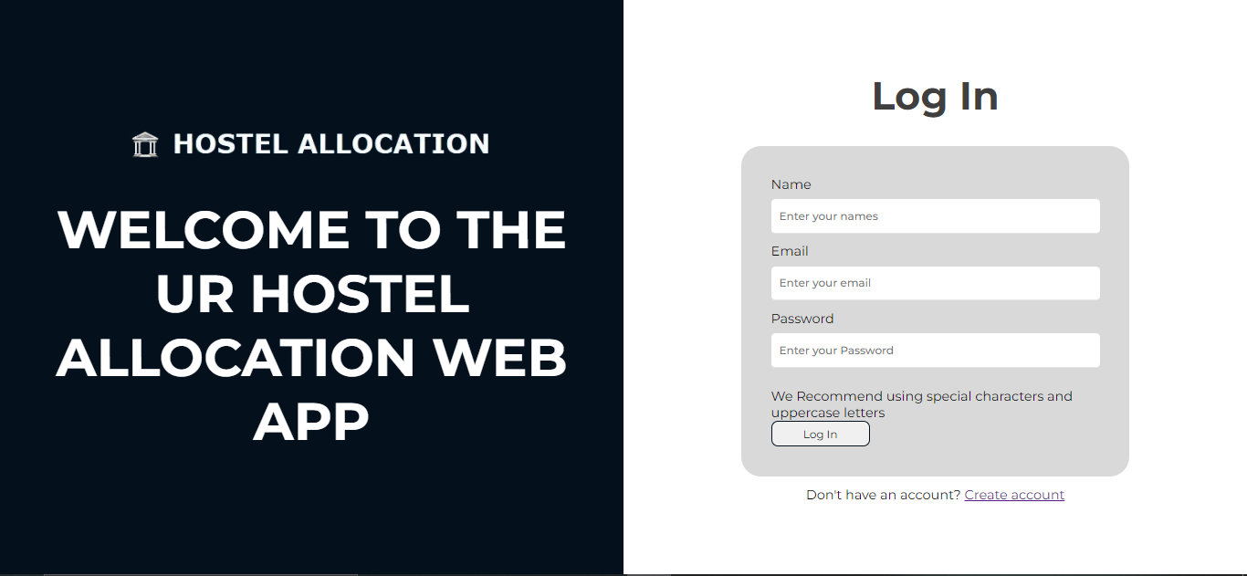

Figure 3: Login page

## Apply for Accommodation page

From the image, you can see the multiple input fields that the user will enter information in, and that information will be sent to the database.

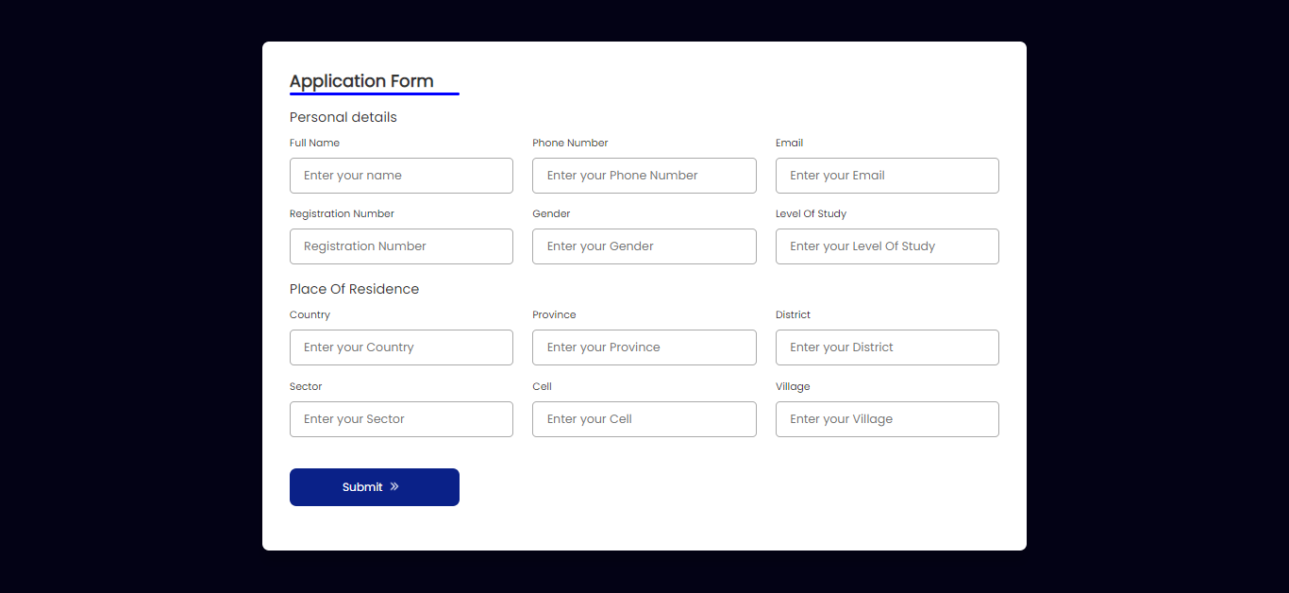

Figure 4: Application for Accommodation

## Feedback Page

The feedback page is where users can/ will be able report any problems they had or will be able to propose some improvements to the system.

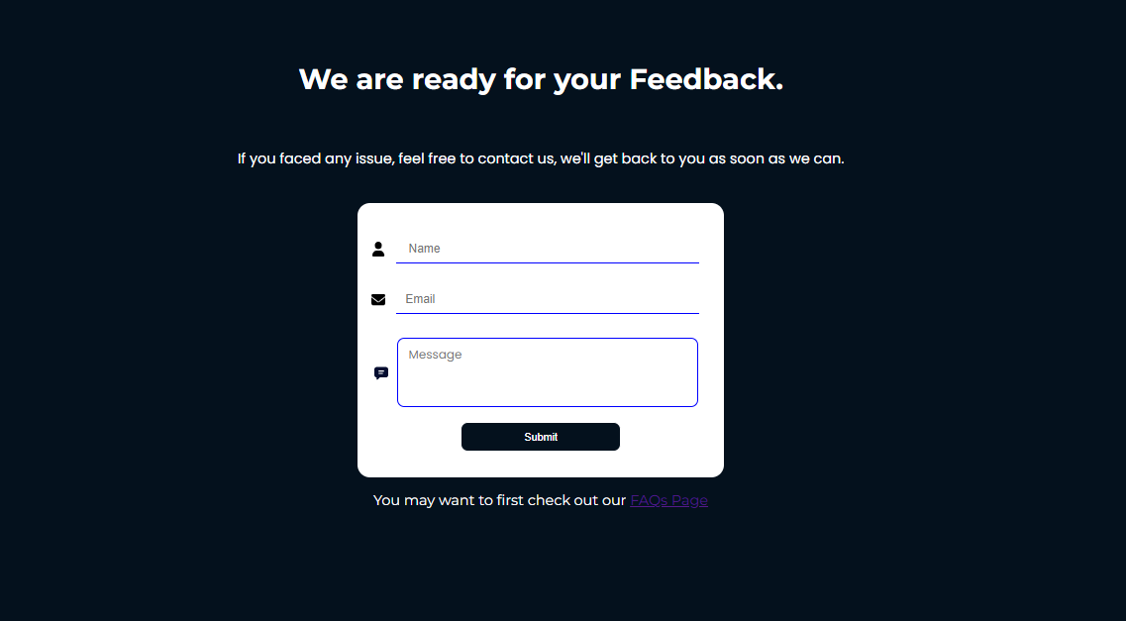

Figure 5: Feedback Page

## FAQs(Frequently Asked Questions)

The FAQs page will contain the most asked questions from users from the feedback and it will be updated by the admin. The page will also contain the answers to the questions.

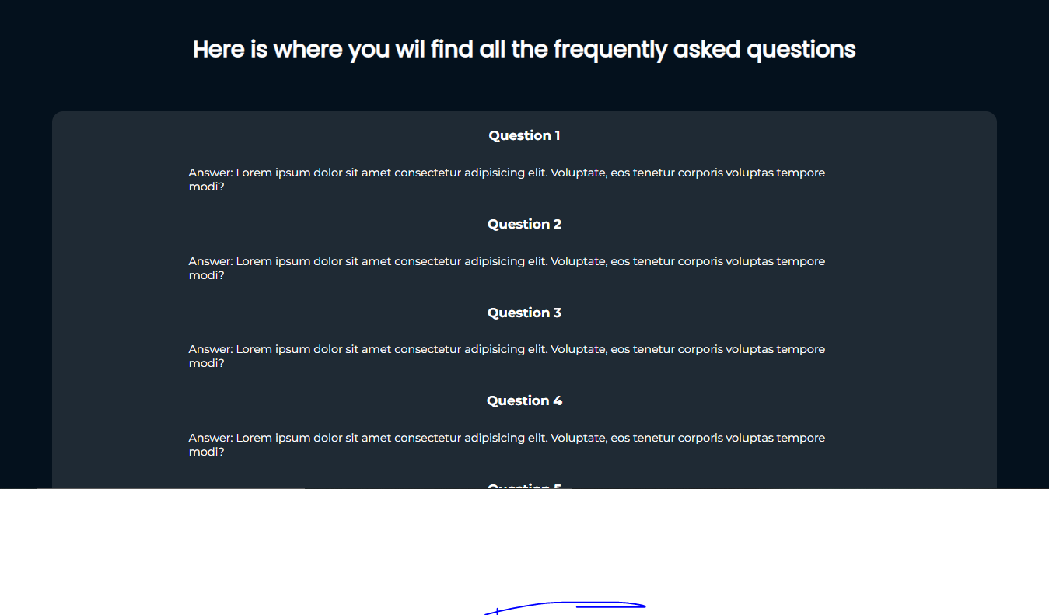

Figure 6: FAQs Page

## Contacts

This page will consist of the relevant contacts that a user can contact in case of a problem or in need much more deep information. It will be updated by the admin.

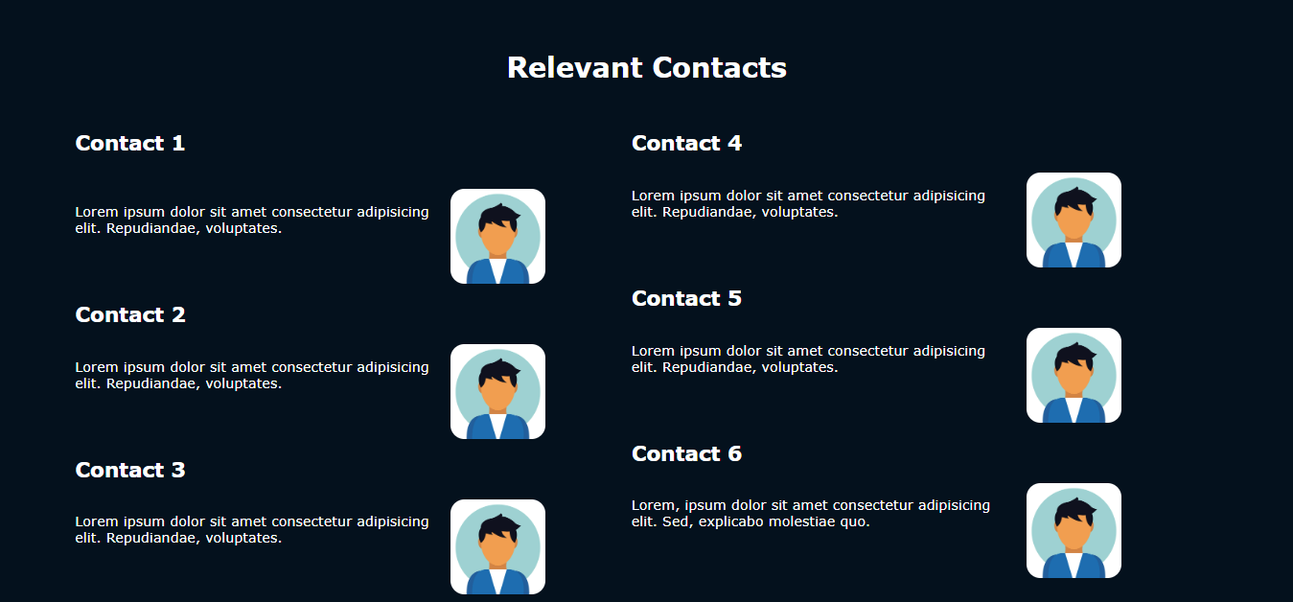

Figure 6: Edit option

# Conclusion

* The project manages to solve the mentioned problem to an 85% level due to external factors.
* Project composition: HTML(54.6%), CSS(34.0%), PHP(11.4%).

# Recommendation:

1. **Other students: All**  students of the university of rwanda
2. **Department: URSU**
3. **Beneficiaries** : University Of Rwanda, UR students,

# Appendix

* Link for your GitHub account with your project, if there is a need of password share it too.
* **GitHub account:** https://github.com/IGIRANEZAJosue
* **Project Link:** <https://github.com/IGIRANEZAJosue/Hostel-Allocation-Class-Project->